輸出陣列

ek, eu, e

輸出陣列

x, v, t, f

**初始條件**

k (彈性常數) = 1 (N/m)

x0 (原長) = 10 (m)

m (質量) = 0.1 (kg)

x(1) (初位置) = 12 (m)

v(1) (初速) = 0 (m/s)

t(1) (初始時間) = 0 (s)

**其他條件**

res (阻力) = 0, 0.1, 0.5 (N)

dt (時間間隔) = 0.01 (s)

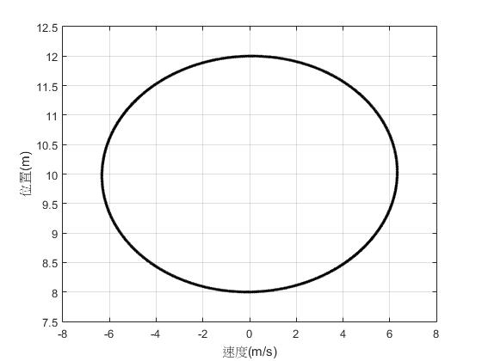

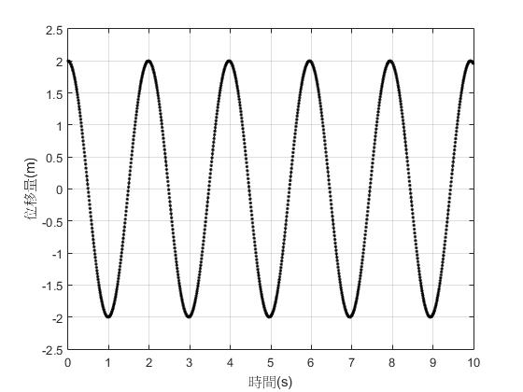

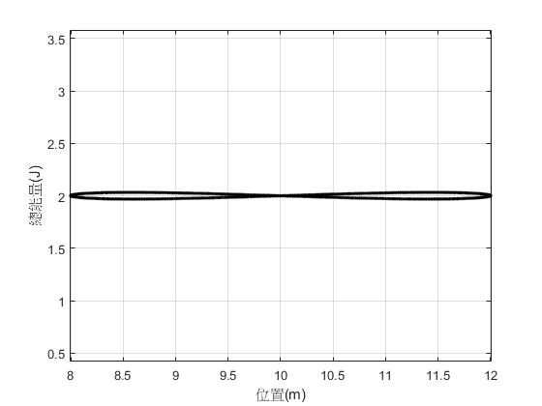

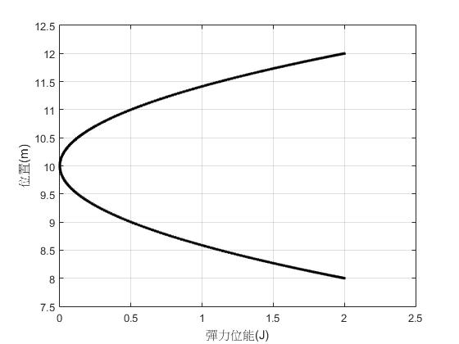

阻力：0 (N)

阻力：0.1 (N)

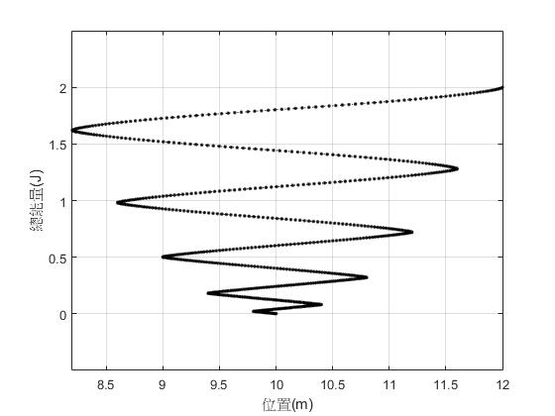

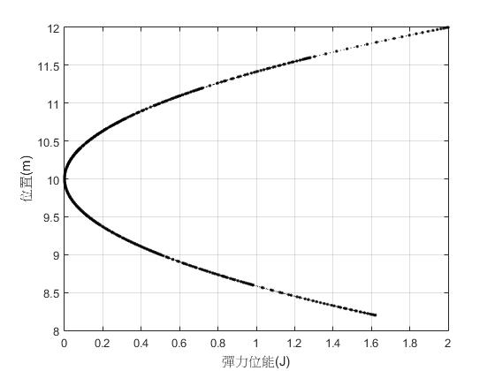

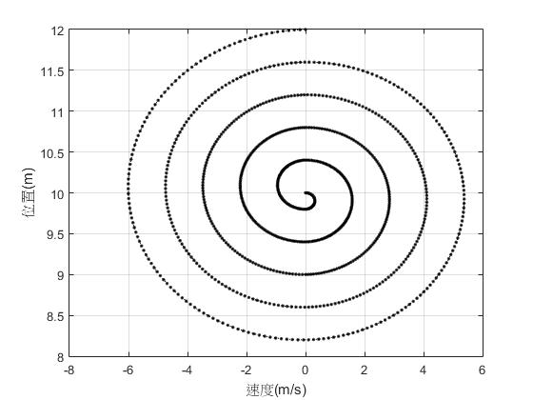

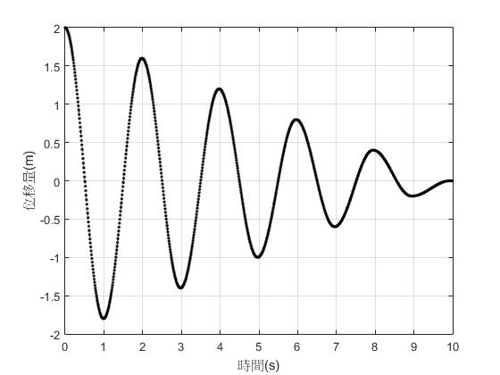

阻力：0.5 (N)

